OVERVIEW
Have you ever looked for God’s guidance in your life? Sometimes it would be nice if God would just speak to us directly! But it doesn’t always work that way. Usually, God speaks to his children through the Bible or through other people. In this lesson, students will learn how they can better hear God’s voice through the story of Samuel. God did speak to Samuel directly: he called out to him in the night, and Samuel answered with, “Speak, for your servant is listening.” Students will learn how they can better hear the voice of God by having faithful, willing, and obedient hearts.
TEACHING

OPENING QUESTION
- When you have to contact someone, what’s your go-to method? Are there times when you change your communication method, depending on the person you’re contacting?

WHAT THE BIBLE HAS TO SAY ABOUT IT
Samuel was a kid with a special job: his mom, Hannah, had given him to the temple priests so he could serve the Lord all his life. You see, Hannah was unable to have children, so she prayed to the Lord that he would give her a son. If he did, she promised to dedicate him to the Lord and send him to serve at the temple. So Samuel worked in the temple for Eli, the high priest.
Facilitator’s Note: It may be helpful to set aside time for the students to read 1 Samuel 1–2 to hear more about Hannah’s story (and the power of prayer) and for background about Eli’s sons (who were disrespectful, dishonorable, and disobedient). Point out how God listens to prayer and when God does or says something, the effects last!

Read 1 Samuel 3.
God communicates with faithful hearts. God would often communicate with the high priests directly. But while Eli was high priest, it was rare that God chose to reveal himself. The Bible doesn’t say exactly why, but we can guess it’s because Eli was allowing his sons to steal from the offerings. God can communicate with anyone he wants to, but he is more likely to communicate with someone who is walking faithfully with him.
God communicates with willing hearts. God whispered to Samuel three times, but it wasn’t until Samuel said, “Speak, your servant hears” that God gave Samuel his message. God wants to know that you want to listen to him! When you are open and available to what God has to say, it’s easier to listen and respond to him.
God communicates with obedient hearts. Imagine having to tell an authority figure in your life a message like the one God sent Eli through Samuel. The Bible calls it “ear-tingling!” But Samuel bravely did as the Lord told him and gave Eli the message. He obeyed God’s words even though it was hard.
Facilitator’s Note: Josephus, a historian who lived around the time of Jesus, said that Samuel was probably around 12 at the time of this story. Other historians think he may have been older. Either way, he was young enough to be about the same age as your students.¹ Help them understand that Samuel wasn’t really all that different from themselves.
A SECOND LOOK
Pick one of these illustrations to bring the topic to life.

Option 1: Obey You Will
In the movie Star Wars: Episode VIII – The Last Jedi, Poe Dameron is determined to be a hero—to lead his troops into battle, victory or not. He is going to lead the attack on an enemy ship until General Leia Organa, realizing that his mission will only lead to the deaths of good soldiers, orders him to stand down. Dameron refuses, attacks the enemy ship, and loses the battle. Upon seeing his recklessness, Organa demotes Dameron from commander to captain. As the war goes on, Dameron continues to disobey orders. He believes that that Vice Admiral Haldo is refusing to act during a crisis, so he leads a mutiny against her, only realizing later that his actions have exposed Haldo’s covert operations, endangering dozens of people.

Discuss:
- How was Dameron’s refusal to listen harmful?
- How might the battle have gone if Dameron had had a faithful, willing, and obedient heart?
- On a scale of 1–4 (1=rebellious, 4=perfectly obedient), how do you respond to God’s commands in Scripture?

Option 2: Still, Small Voice
When Pinocchio the puppet first comes to life, he meets a little cricket named Jiminy. Jiminy volunteers to be his conscience—the “still, small voice” that will guide Pinocchio through his life. It’s in Pinocchio’s best interests to listen to Jiminy: if Pinocchio proves himself to be good enough, he will become a real, live boy, no longer a puppet. Unfortunately, instead of eagerly listening to Jiminy, over and over he chooses to do exactly the opposite of what Jiminy suggests. Pinocchio meets some other boys who take him to Pleasure Island where they smoke and drink and end up cursed, turning into donkeys. Pinocchio is eventually rescued, but only after he finally listens to Jiminy.

Discuss:
- How would have listening to Jiminy Cricket the first time helped Pinocchio?
- How is Jiminy Cricket’s role in Pinocchio’s life like God’s role in your life?
- Do you have someone in your life who acts as your accountability partner or spiritual mentor, encouraging you to do the right thing?
Facilitator’s Note: If your students express interest in having an accountability partner or spiritual mentor, it would be a good idea to have people or resources in mind to help connect them with someone.

THE TAKEAWAY
God communicates with us, and it's our job to listen and respond.

DISCOVER
- Share about a time when you sensed God speaking to you clearly.
APPLICATION

THE BIBLE IN YOUR LIFE
God speaks to his people in many different ways, the most common being through the Bible (his Word) and through other believers (like when Eli told Samuel how to respond). But in order for you to hear God’s voice well, your heart needs to be faithful, willing to listen, and obedient to what he says.
Read 1 Samuel 3, then answer the following questions.
Discuss:
- What did Eli tell Samuel to say to God? Why is that important?
- How can you know if a message is truly from God?
- What are some more unusual or rare ways God can speak to people?
- What are some ways you can show God that you’re ready to listen to him?
Facilitator’s Note: Read 1 John 4:1–6 for further clarification on how to know if a message is from God or not. If the message you’re hearing contradicts God’s Word, it’s not from God. A great resource to use is the True or False? lesson from the Warped series in Vantage, another year-long curriculum in the Deep Discipleship family.

APPLY IT
The main way God communicates with us today is through his Word. Have you taken time to listen to what God has to say to you by reading your Bible? Spend some time reading 1 John 4 this week as you learn how you might listen to God.
Be specific:
- What are you going to do?
- When are you going to do it?
- Is there someone who can keep you accountable?

PRAYER
Take time to let your students pray for each other’s applications in the upcoming weeks.

A QUOTE TO THINK ABOUT
“The willingness to obey every word from God is critical to hearing God speak.” – Henry T. Blackaby

THE TAKEAWAY
God communicates with us, and it's our job to listen and respond.

Here are some tools that you can use to follow up with your students throughout the week. For example, send any of the graphics included in your download to your students later this week to keep the conversation going.
WAYS TO FOLLOW UP

MEMORY VERSE
“Call to me and I will answer you, and will tell you great and hidden things that you have not known.”
Jeremiah 33:3 (ESV)
MARK OF A DISCIPLE  Marks of a Disciple are a great way to figure out whether your students are growing in their understanding of God’s story and how to connect it to their daily lives. As Scripture impacts your students’ hearts, they’ll begin to live differently, and these Marks of a Disciple are a great guidepost to help them grow more Christ-like. Periodically check in with your students about one or two of these Marks of a Disciple that seem to be speaking to them specifically in this season. |  | 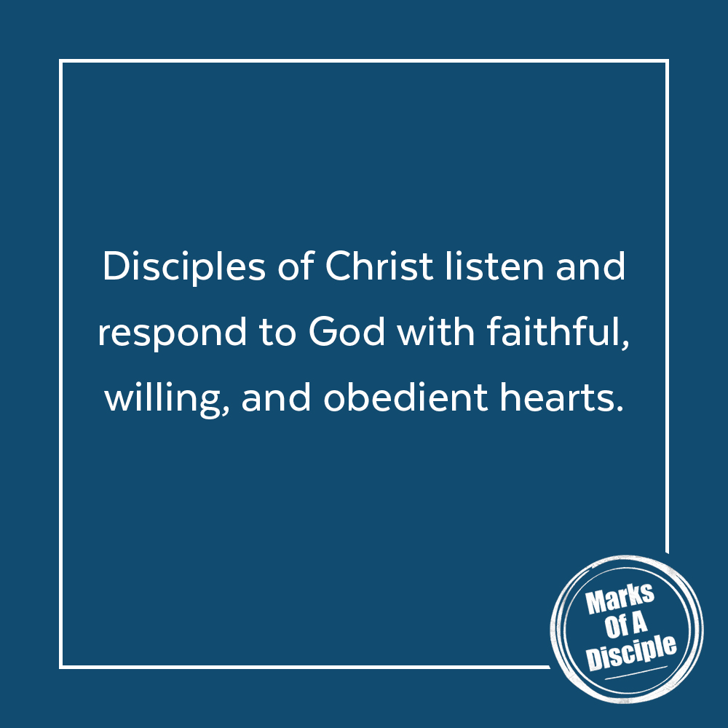

Scripture quotations are from the ESV® Bible (The Holy Bible, English Standard Version®), copyright ©2001 by Crossway, a publishing ministry of Good News Publishers. Used by permission. All rights reserved. May not copy or download more than 500 consecutive verses of the ESV Bible or more than one half of any book of the ESV Bible.
Any reference within this piece to Internet addresses of websites not under the​ ​administration of LeaderTreks is not to be taken as an endorsement of these​ ​websites by LeaderTreks;​ ​neither does LeaderTreks vouch for their content.

¹ Walter C. Kaiser and Duane Garrett, eds., NIV Archaeological Study Bible: An Illustrated Walk through Biblical History and Culture (Grand Rapids: Zondervan, 2005). “Star Wars: The Last Jedi,” Wikipedia, accessed May 1, 2020, https://en.wikipedia.org/w/index.php?title=Star_Wars:_The_Last_Jedi&oldid=953581240.
“Jiminy Cricket,” Disney Wiki (Fandom), accessed May 1, 2020, https://disney.fandom.com/wiki/Jiminy_Cricket.
Henry T. Blackaby and Richard Blackaby, Hearing God's Voice (Nashville: B&H Publishing, 2002), 53.

