HOWDY! WE’RE SO GLAD YOU’RE HERE TODAY. USE THIS PAPER TO GET

MORE OUT OF THIS BIBLE STUDY AND TAKE IT HOME TO REMEMBER WHAT WE LEARNED.

USE THE SECTION BELOW TO WRITE DOWN IMPORTANT THINGS FROM TODAY:

Notes:
_____________________________________________________________________________________________________
_____________________________________________________________________________________________________
_____________________________________________________________________________________________________
_____________________________________________________________________________________________________
_____________________________________________________________________________________________________
_____________________________________________________________________________________________________

THE BIBLE IN YOUR LIFE
Read James 4:1–10, then answer the following questions.

Answer:
What does it look like to draw near to God?

What are some things that might keep you from having a close relationship with God? Look for specific examples in the passage.

What are some things that might keep you from having a strong relationship with the people around you?
APPLY IT  Decide on two ways you can work together with your friends to have a stronger relationship with God this week. | Be specific:  What are you going to do?  When are you going to do it?  Is there someone who can keep you accountable?

PRAYER
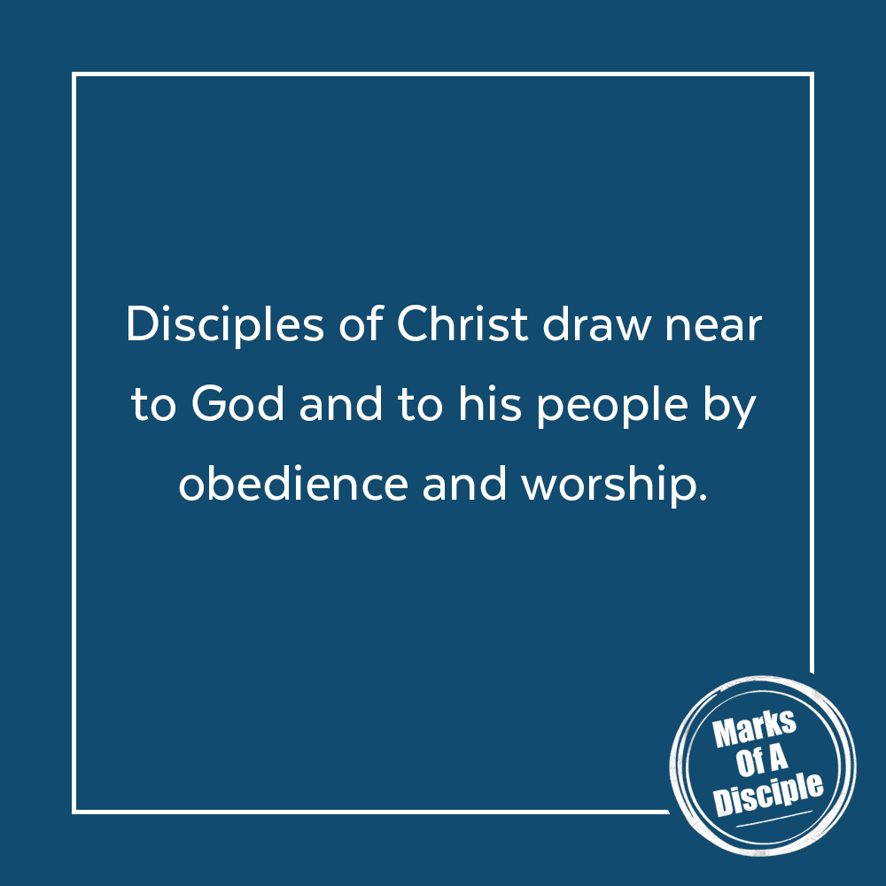
We may or may not pray during Bible class today, but we encourage you to pray each day about things going on in your life, in the life of your family and in the lives of your friends.
THE TAKEAWAY
God promises to draw near to us as we draw near to him and his people.

MEMORY VERSE
“Draw near to God, and he will draw near to you.”
James 4:8 (ESV)

A QUOTE TO THINK ABOUT
“The Christian life from start to finish is based upon this principle
of utter dependence upon the Lord Jesus.”
– Watchman Nee

ANNOUNCEMENTS
Today – Everyone is invited to sit in the youth section during 2nd service.

Tonight – Intersection (youth worship for all MS & HS students) begins at 7:00pm in the youth
rooms. Come. Bring friends. Bring a Bible.

Wednesday Night – Midweek Youth begins at 7:00 in the youth rooms. Get your homework
finished early and join us.

Old Youth T-shirts – today and Wednesday we’ll have old youth group t-shirts for sale for $2 each. They’re on the serving cabinet. If you buy one, put your $2 in the youth box (in-wall lockbox by the windows near the HS Room door.)

Pictures – from the Back to School Parade, Fireworksapalooza, and the Cardboard Boat Race can be found at amyouth.smugmug.com Also, pics from Mega Days and Trek are now on bulletin boards in the Great Hall.

