OVERVIEW
The 12 disciples didn’t have much, but when Jesus told them to follow him, they agreed and gave up everything—their livelihoods, their families, their homes—to follow him. In this lesson, students will compare and contrast the disciples with the rich young ruler who decided he wasn’t willing to give up what he had for eternal, heavenly treasures. Students will learn that Jesus wants obedience, commitment, and sacrifice, and be challenged to consider what that can look like in their own lives.
TEACHING

OPENING QUESTION
- If you were given the choice between free, “average” food for a year or a day of perfect meals made by the world’s best chef, what would you choose and why?

WHAT THE BIBLE HAS TO SAY ABOUT IT
Have you ever had to sign a contract or a covenant in order to participate in an activity? Some schools make their athletes sign “no partying” contracts in order to allow them to participate in the programs. Each athlete has to decide if it’s worth it to them to give up certain opportunities in order to be allowed to play. (Sometimes this is pretty easy: a lot of the behavior they are signing away is illegal or otherwise harmful.) Following Jesus can seem similar, but the stakes are much higher, and the rewards are eternal.
Read Matthew 4:18–22. Make note of what the disciples gave up to follow Jesus.
Now read Matthew 19:16–30. Make note of what the rich young man was asked to give up for Jesus. Jesus asked the same thing of the rich young man as he had asked his disciples.
Facilitator’s Note: We know the disciples were probably teenagers, but they were already working full time with their families. We don’t know much about the rich man’s age other than that he was “young,” but he was likely not much older than some of your older high school students. This passage does not mean that a rich person can’t be saved, just that it is much harder for a rich person to recognize their own need for Jesus. Money can be a powerful thing that does a lot of good in the world, but it can also blind us to our need for God.

Following Jesus requires obedience. When Jesus saw the disciples, he gave them one brief command: follow me. The disciples immediately did as he said. The rich young ruler, of course, also claimed to have obeyed the Ten Commandments. Obedience is what Jesus expects of us, but it’s not the only thing.
Following Jesus requires commitment. When the disciples left their boats, they were giving up their jobs and their security. There was no guarantee that their boats would be waiting for them when they got back—they were committed to Jesus for the long haul.
Following Jesus requires sacrifice. Jesus wants to be our first priority. He wants us to value our relationship with him above everything else in our lives. Truly following Jesus means we might need to give up things that we love in order to keep our hearts focused on him, not idolizing anything else above Jesus. The rich young ruler walked away sad because he knew he loved his stuff more than he loved Jesus.

A SECOND LOOK
Pick one of these illustrations to bring the topic to life.
Facilitator’s Note: This lesson touches on the reality that eternal rewards outweigh any sacrifices we make here on earth to follow Jesus. To more fully explore this topic, check out the Abundant Life series, also a part of this Pursuit curriculum.

Option 1: Follow Your Coach
One day Gabby Douglas was watching Olympic gymnastics with her family. She had been training in gymnastics for years, but on this day, she felt particularly inspired. She realized that with a little help, she could do exactly what the women on TV were doing. She knew she was capable of making it to the Olympics. But Gabby knew that if she was going to go further in her gymnastics career, she would need to find a gym with a coach that had her back. She and her family started researching gymnastics coaches that had brought women all the way to a gold medal. They found Coach Liang Chow. The only problem was that he worked out of a gym in Iowa, and Gabby lived with her family in Virginia Beach. Gabby and her family had a family meeting, and they decided it was worth it for her to move to get the training she needed.

Discuss:
- Do you have a goal which you would give up everything to pursue?
- How do you think it felt for Gabby to leave her family and her life in Virginia Beach to pursue her goals?
- What are you willing to give up to follow Jesus? What are you unwilling to give up?

Option 2: Worthy Sacrifice
Viola Liuzzo was an activist in Michigan during the civil rights movement. One day while she was watching the news with her husband, she saw a report on Bloody Sunday—the day of the brutal assault on civil rights protestors in Selma, Alabama. That day, Viola was compelled to join Dr. Martin Luther King Jr. in the fight for civil rights. She probably knew it could be dangerous—Viola had seen firsthand some of the difficulties that African Americans faced, especially in the South. But she decided to give her all for this important cause. One day, as part of her volunteer work, Viola was driving with another volunteer, Leroy Moton, when a car filled with Ku Klux Klan members pulled up beside her. Seeing a white woman (Viola) and a black man (Leroy) in a car together, the KKK members pulled out a gun and shot into the car, missing Leroy but hitting Viola. Viola died that day in the service of a cause she cared deeply about.

Discuss:
- Have you ever put yourself in the way of danger for an important cause? Would you?
- How does Viola’s sacrifice mirror the disciples’ sacrifice?
- Viola gave up everything to follow Dr. Martin Luther King. Why is Jesus even more worthy of giving up everything for?

THE TAKEAWAY
Truly following Jesus requires committing to the relationship,
obeying what he says, and sacrificing anything that gets in the way.

DISCOVER
- What’s your most prized possession? What would you do if someone asked you to give it up?
APPLICATION

THE BIBLE IN YOUR LIFE
When Jesus called the disciples, they left everything and followed him, no hesitations. When he gave similar instructions to the rich young man, he couldn’t give up his wealth. Following Jesus requires our obedience, commitment, and sacrifice. It’s not always easy, but the rewards are eternally worth it.
Read Matthew 4:18–22 and Matthew 19:16–30, then answer the following questions.
Discuss:
- Why do you think it was harder for the rich young man to give up his possessions than it was for the disciples?
- What does “many who are first will be last, and the last first” mean?
- Is it better to have treasure on earth or in heaven? Why?
- Consider your own walk with Jesus. In what parts of your life do you struggle to obey, commit, and sacrifice for Christ?

APPLY IT
What things do you have in your life that might be standing in the way of you completely following Jesus? Take some time to identify the idols in your life and decide on a few steps on how to put Jesus first again.
Be specific:
- What are you going to do?
- When are you going to do it?
- Is there someone who can keep you accountable?

PRAYER
Take time to let your students pray for each other’s applications in the upcoming weeks.

A QUOTE TO THINK ABOUT
“What good would it be if you had everything, But what you didn’t have was the only thing you need?”
– Mark Stuart/Audio Adrenaline

THE TAKEAWAY
Truly following Jesus requires committing to the relationship,
obeying what he says, and sacrificing anything that gets in the way.

Here are some tools that you can use to follow up with your students throughout the week. For example, send any of the graphics included in your download to your students later this week to keep the conversation going.
WAYS TO FOLLOW UP

MEMORY VERSE  “For what will it profit a man if he gains the whole world and forfeits his soul? Or what shall a man give in return for his soul?”  Matthew 16:26 (ESV) |  | 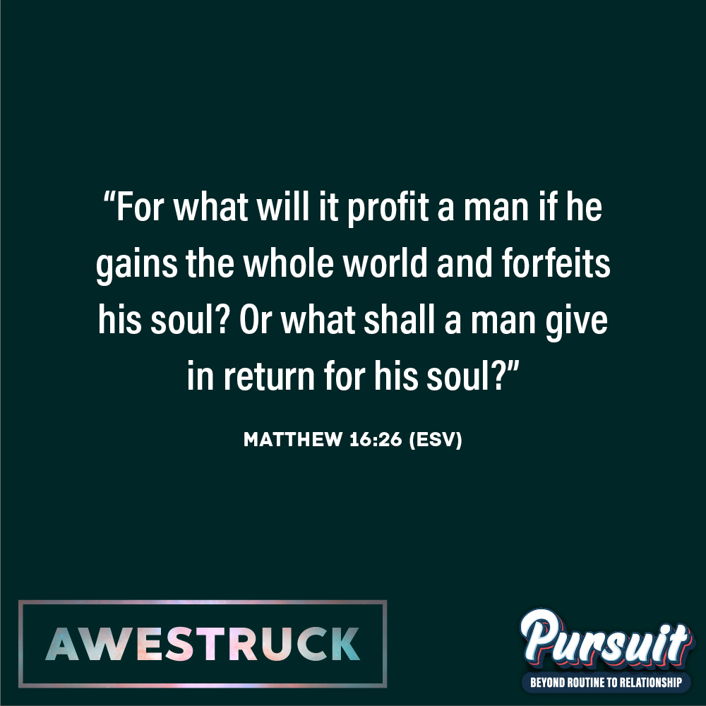
MARK OF A DISCIPLE  Marks of a Disciple are a great way to figure out whether your students are growing in their understanding of God’s story and how to connect it to their daily lives. As Scripture impacts your students’ hearts, they’ll begin to live differently, and these Marks of a Disciple are a great guidepost to help them grow more Christ-like. Periodically check in with your students about one or two of these Marks of a Disciple that seem to be speaking to them specifically in this season. |  | 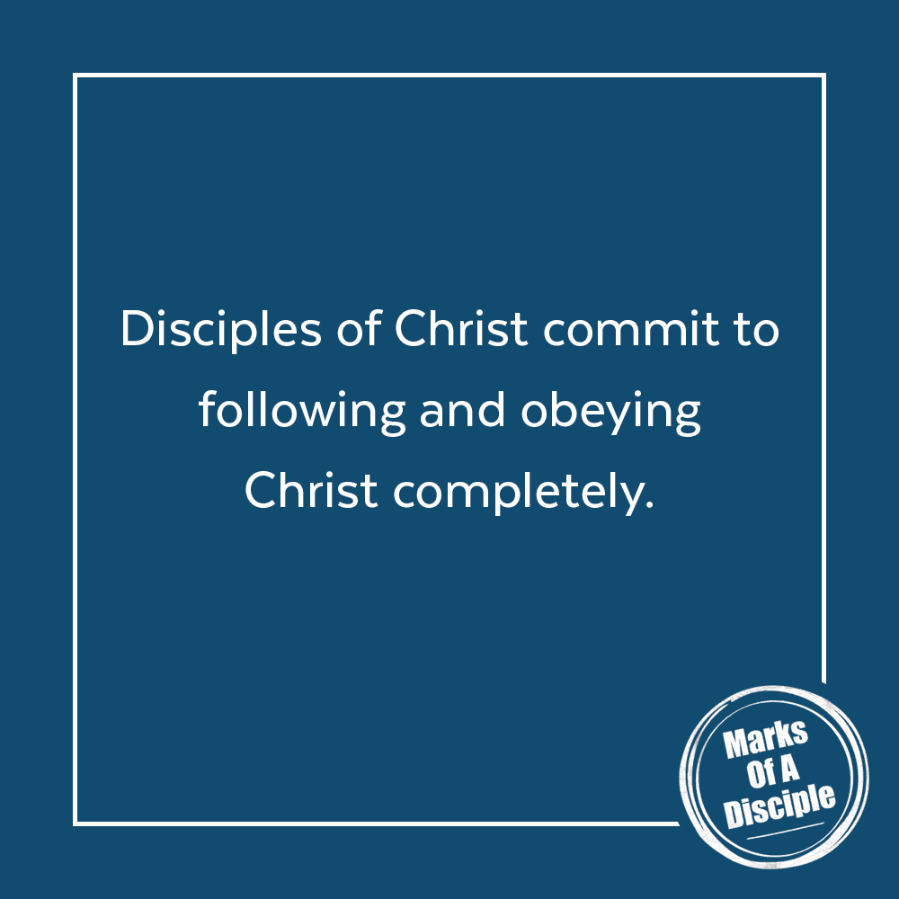

Scripture quotations are from the ESV® Bible (The Holy Bible, English Standard Version®), copyright ©2001 by Crossway, a publishing ministry of Good News Publishers. Used by permission. All rights reserved. May not copy or download more than 500 consecutive verses of the ESV Bible or more than one half of any book of the ESV Bible.
Any reference within this piece to Internet addresses of websites not under the​ ​administration of LeaderTreks is not to be taken as an endorsement of these​ ​websites by LeaderTreks;​ ​neither does LeaderTreks vouch for their content.

“Gymnast Gabby Douglas' mom on Olympic sacrifices,” YouTube video, August 12, 2012, www.youtube.com/watch?v=lclLCTF_2Q0.
“Viola Liuzzo,” Wikipedia, accessed May 1, 2020, https://en.wikipedia.org/w/index.php?title=Viola_Liuzzo&oldid=951952111.
Mark Stuart, Bob Herdman, Will McGinniss, Charlie Peacock/Audio Adrenaline, "Good Life," track 4 on Underdog, Forefront Records, 1999, compact disc.

