Hey – Happy September 12 to everyone. Did you know September is the 9th month of the year? And it has 9 letters in it. It’s the only month like that. You’ve probably been going through this whole month and haven’t known that yet. But see, you always learn cool things at church. Bible study will have plenty to learn this morning as well. Glad you’re here.

Notes:
_____________________________________________________________________________________________________
_____________________________________________________________________________________________________
_____________________________________________________________________________________________________
_____________________________________________________________________________________________________
____________________________________________________________________________________________________

WHAT THE BIBLE HAS TO SAY ABOUT IT
Read Exodus 3:1–15 and 4:1–17, then answer the following questions.

Answer:
How did God handle Moses’ objections (both his honesty and his disobedience)?

Have you ever asked God any heartfelt questions? What happened?

What’s encouraging about the truth that you can be real with God?

In what areas of your life is it hardest to be honest with God?
APPLY IT  In the previous discussion, you just identified areas of your life where it’s hard to be honest with God. Pick one area to focus on this week. How can you draw near to God by being completely honest with him? | Be specific:  What are you going to do?  When are you going to do it?  Is there someone who can keep you accountable?

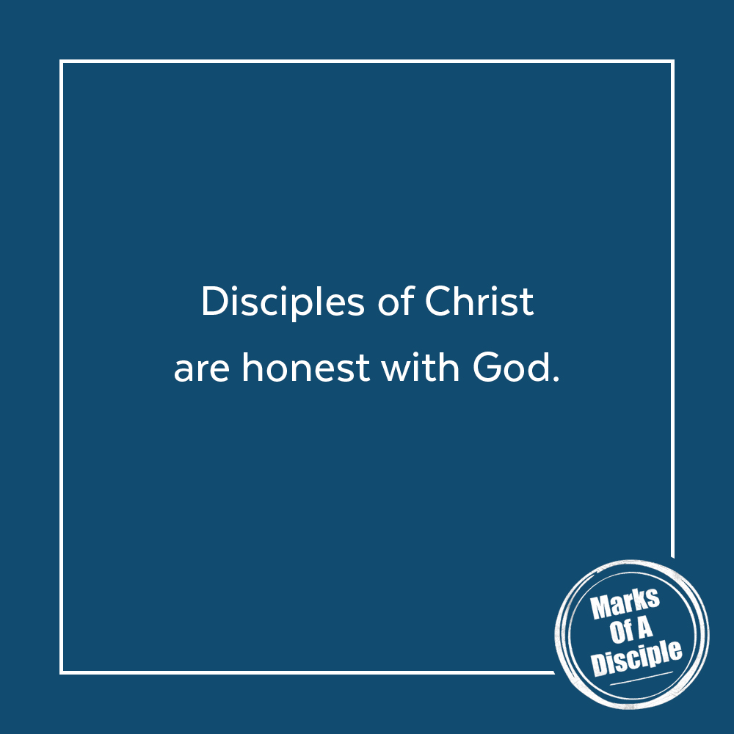
PRAYER
Take time to pray for each other’s application steps in the upcoming weeks.
THE TAKEAWAY
Honesty in relationships is important. We can be real with God—he can handle it.

MEMORY VERSE
“I cry aloud to God, aloud to God, and he will hear me.”
Psalm 77:1 (ESV)

A QUOTE TO THINK ABOUT
“If we can’t bring our real selves to the real God, who else can
we turn to? He will hold us and be near.” – Rend Collective

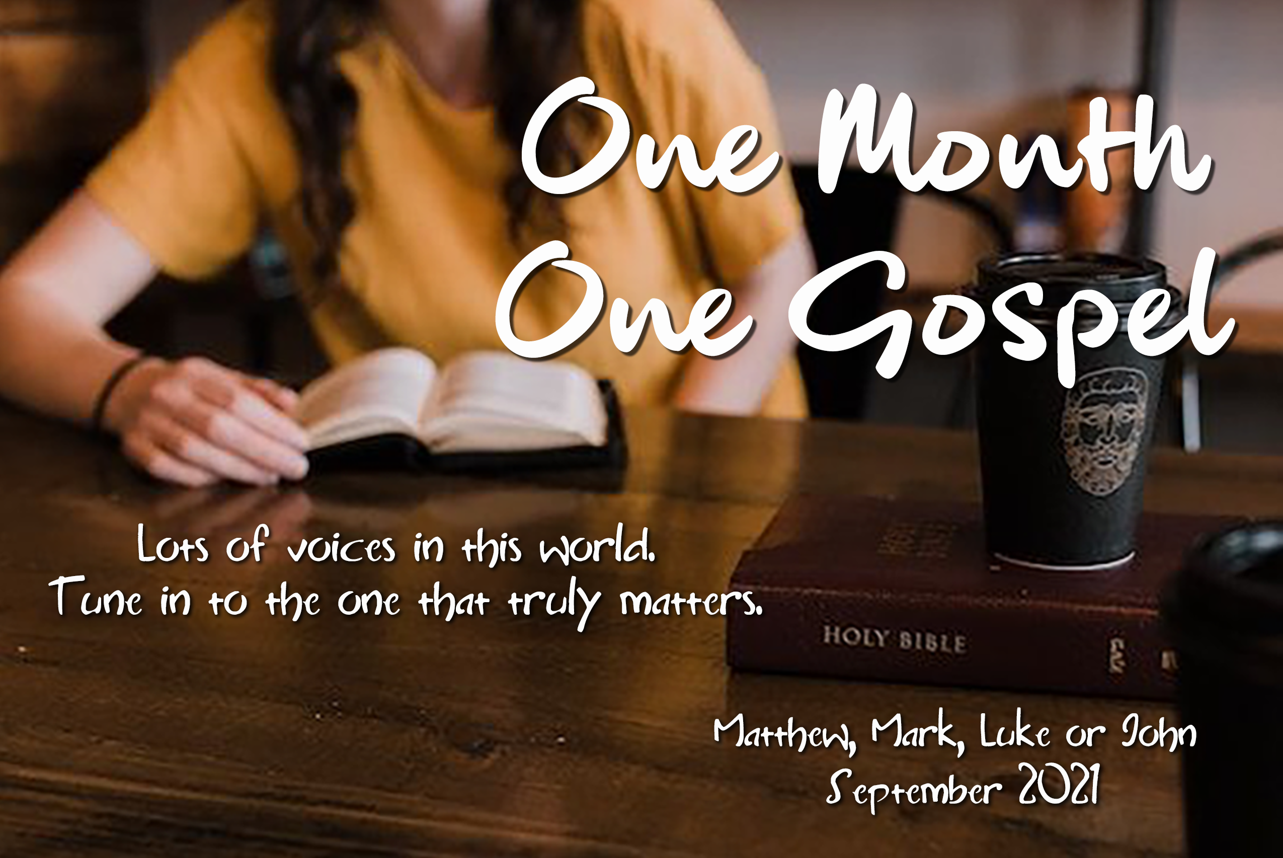
AM.YOUTH ANNOUNCEMENTS – 9.12.21

Today – Everyone is invited to sit in the youth section during 2nd service.

Tonight – Intersection at 7:00pm. For all MS & HS.

One Month, One Gospel – Read Matthew, Mark, Luke, or John during
September. Choose when to read. Choose what Gospel to read.
And let the Word of God speak into your life.

Wednesday Night – Midweek at 7:00pm. Get your homework done early
and finish your chores early or late, but don’t miss Midweek. All MS & HS.

Pictures – A new bulletin board is up in the Great Hall with pictures
from the Cardboard Boat Race, Fireworksapalooza, and the Back to
School Parade. Also, all youth pics can be found at amyouth.smugmug.com

